Building with AI

Step1:

1. Download Anaconda Distribution - Manages your project files  
   [Download Anaconda Distribution | Anaconda](https://www.anaconda.com/download)

* Provide email to download distribution
* Agree
* Submit
* Open email
* Download for MacOs Apple or Microsoft Intel

1. Python - Allows your computer to run python scripts   
   [Download Python | Python.org](https://www.python.org/downloads/)

* Click on Downloads
* Download python latest version MacOs or Microsoft

1. Node.JS - Allows your computer to run Node JS scripts  
   [Node.js — Run JavaScript Everywhere](https://nodejs.org/en)

* Download Node.js

1. Cursor AI - Use this to write code with AI  
   [Cursor - The AI Code Editor](https://www.cursor.com/)

* Download for Free

1. v0.dev - Use this to create beautiful user interfaces for your projects  
   [v0 by Vercel](https://v0.dev/)

* Sign up

1. GitHub - Use this to save your code  
   [GitHub · Build and ship software on a single, collaborative platform · GitHub](https://github.com/)

* Enter email and sign up

1. Open Cursor

* For MacOs – Create new folder on desktop: TEST
* For Microsoft – Create folder first on desktop and then open Cursor (find desktop folder you just created)



* Type in: I want a file that when I run it, it creates a print Morning



* Instead of Morning, I want it to say Hello World
* After printing Hello World as me 3 questions about myself



* I want you to remove the extra questions
* Click Apply

1. In the Chat: Create next js project called Celebration

* Copy
* Terminal 🡪 New Terminal
* Paste and replay yes, yes, yes, yes, yes
* Click Run cd
* Click Run npm
* Click on 🡪 app 🡪 page.tsx
* Delete all that is in command
* Type in: Create a Simple Celebration message on this page in the centre
* Click on <https://nextjs.org/docs/messages/moudule-not-found>
* Close page.module.css at the top

1. Open v0.dev

* Create a simple button that when clicked shoots gold confetti everywhere, button should say celebration
* Copy

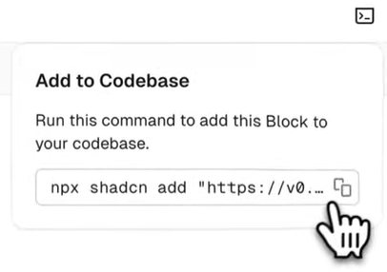

* Add +
* Type cd celebration
* Paste codebased from v0.dev 🡪 yes, yes, yes,
* Delete and add @confetti-button
* Type in: lets add this button to this page
* Accept